SINGAPORE MEDICAL ASSOCIATION  SMSI-PGY1/2019  MEMBERSHIP APPLICATION (2019)  2985 Jalan Bukit Merah #02-02C SMF Building, Singapore 159457  Tel: 6223 1264 Fax: 6252 9693 Email: sma@sma.org.sg Website: www.sma.org.sg | 
Membership Type: Ordinary Membership □ New □ Conversion

PERSONAL PARTICULARS
Salutation: Dr |  | NRIC/Passport/FIN No.:
Full Name (as in NRIC/FIN/Passport) :  * Underline Surname: |  | Nationality:
 |  | Date of Birth:
Race: | Religion: | Gender: □ Male □ Female
Marital Status: □ Single □ Married □ Separated □ Divorced □ Widowed □ Others: ______________

HOME ADDRESS (Local Address)
Address:  Postal Code [ ] | Tel:
Address:  Postal Code [ ] | Fax:
Email: | Mobile:

PROFESSIONAL QUALIFICATIONS
Country of Graduation:  Ireland | Year of Graduation:  2019
Medical School/ University: | Year of Graduation:  2019

PRACTICE ADDRESS

Name of Organization (1st Posting): *please circle

* NUHS / NHG / SINGHEALTH / OVERSEAS

Name of Hospital : ____________________________________________________

…..cont’d Page 2 →

MEMBERSHIP GIFTS
Convert to Ordinary Membership by 31 August 2019 to enjoy half year rate and receive these attractive gifts too!
- SMA 32GB USB Thumbdrive (worth $30)
- SMA Lanyard
- SMA Car Decal
- Complimentary 6-month AIA Solitaire Lite Plan**
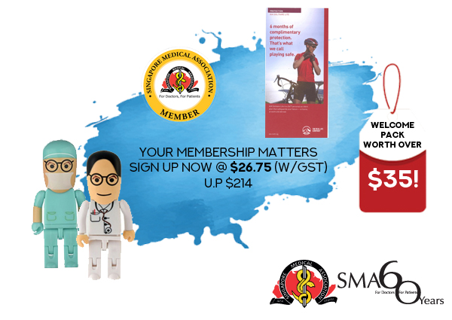

** I agree to be contacted by SMA’s partner to enjoy 6 months of complimentary worldwide protection with AIA Solitaire Lite, a personal accident plan that takes care of medical bills due to accident-related injuries.

PAYMENT MODE & VERIFICATION
Payment for | ½ Year Membership: $26.75 (Half Year rate from July to December 2019)  (Subsidised rate for doctors in training who graduated in 2019: $53.50;  full Ordinary Membership fees: $214.00)
□ CASH □ CHEQUE (Cheque No. ____________________ )
□ CREDIT CARD (VISA/MasterCard Only) :

Credit Card No.:
 |  |  |  | - |  |  |  |  | - |  |  |  |  | -

Expiry Date: |  | (MMYY) | Security No.: |  | (last 3 digits behind the credit card)
I, the undersigned, confirm that the facts and details provided are true and accurate to the best of my knowledge. As a member of SMA, I agree to be bound by the SMA Constitution at all times.
I understand that my SMA Membership is based on an auto renewal basis at the start of each calendar year. Any requests regarding your membership status should be sent in writing via mail or to membership@sma.org.sg, subject to approval from the SMA Council.
Signature of Applicant: |  |  |  | Office Use Only
 |  |  |  | Date Received: |  | Welcome Pack:
 |  |  |  | Receipt No.: |  | Receipt Date:
Date: |  |  |  |  |  | Receipt Date:

